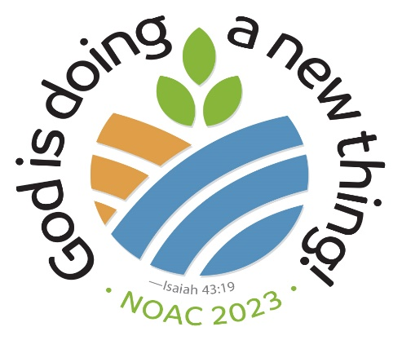 NOAC DVD ORDER FORM
Please check the line next to the DVD’s you would like to order. Cost is $2.00 per DVD. $5 total for shipping. Checks payable to: David Sollenberger.

___ Bible Studies (3 sessions, Christina Bucher & Bob Neff)
Worship Services:
___ Monday (Jeremy Ashworth)
___ Tuesday (Christina Singh)
___ Wednesday (Deanna Brown)
___ Thursday (Lexi Aligarbes)
___ Friday (Katie Shaw Thompson)
Keynote Presentations:
___ Tuesday (Mark Charles)
___ Wednesday (Ken Medema & Ted Swartz)
___ Thursday (Osheta Moore)

Total Number of DVD’s:________ Total Cost:_______________
NAME_______________________________________________
EMAIL:______________________________________________
PHONE NUMBER:_____________________________________
MAILING ADDRESS:____________________________________
____________________________________________________

