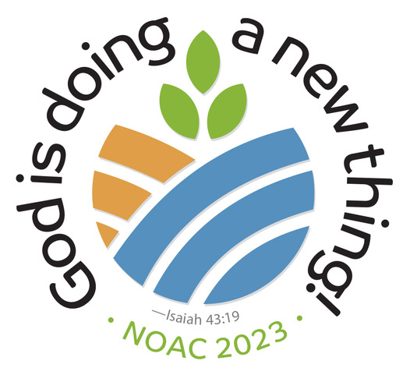MAIL ORDER FORM FOR SUMMARY VIDEO AND
NOAC NEWS
A DVD of NOAC images and all NOAC News segments will be available after NOAC (for $5 plus $5 shipping). Make checks payable to: David Sollenberger. Fill out this form and drop it off along with your payment in NOAC Information Center, the Information Kiosk at the entrance to Stuart Auditorium, or at the NOAC News table at the back of Stuart Auditorium OR mail it with payment after NOAC to:

NOAC News Team
C/O David Sollenberger
1701 Horseshoe Pike
Annville, PA 17003

NAME_____________________________________
ADDRESS__________________________________
PHONE NUMBER (in case we can’t read your writing:)

Email address____________________________________

Would you like a download link for the DVD, instead of getting a DVD in the mail? (yes ) (No thanks )

Download version saves $5.00 shipping. Pay $5.00 total instead, IF an E-mail address is included.

