Children’s Disaster Services
601 Main Street, PO Box 188
New Windsor, Maryland 21776
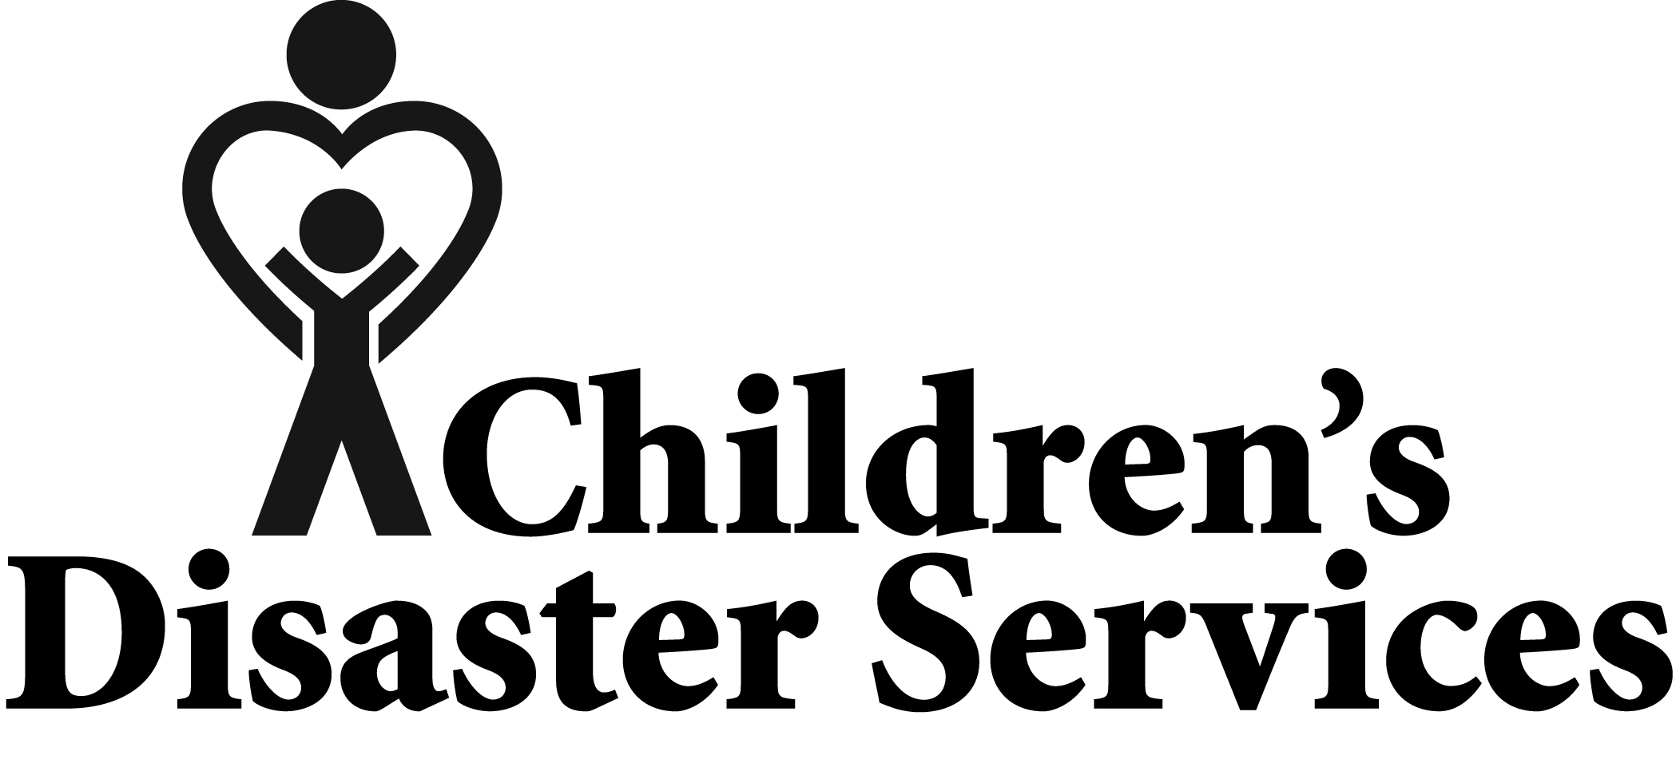
1-800-451-4407 or cds@brethren.org
Volunteer Expense Statement
(this form is available online)
Pay To: |  |  | Name:
 |  |  | Address
 |  |  | City: |  |  |  |  |  | State/Province |  |  |  |  |  | Zip Code
 |  |  | Phone #
Expenses for:
Signature: |  |  |  |  |  |  |  |  |  |  |  |  |  | Date
Itemization
(Receipts must be attached for each item to be reimbursed)
Date |  |  |  | Expense |  |  |  |  |  |  |  |  |  |  |  |  | Amount
 |  |  |  | Private auto: # miles  ($.625 per mile) updated July 2022 |  |  |  |  |  |  |  |  |  |  |  |  | $
 |  |  |  | Airfare: From: |  |  |  |  |  |  | To: |  |  |  |  |  | $
 |  |  |  | Bus/Taxi: From: |  |  |  |  |  |  | To: |  |  |  |  |  | $
 |  |  |  | Rental Car: |  |  |  |  |  |  |  |  |  |  |  |  | $
 |  |  |  | Tolls/Tips: |  |  |  |  |  |  |  |  |  |  |  |  | $
 |  |  |  | Lodging: |  |  |  |  |  |  |  |  |  |  |  |  | $
 |  |  |  | Meals Total: |  |  |  |  |  |  |  |  |  |  |  |  | $
 |  |  |  | Miscellaneous: |  |  |  |  |  |  |  |  |  |  |  |  | $
 | Expense Total |  |  |  |  |  |  |  |  |  |  |  |  |  |  |  | $
 | Less Donation to Children’s Disaster Services |  |  |  |  |  |  |  |  |  |  |  |  |  |  |  | $ ( )
 | Less Advance 58-1106 |  |  |  |  |  |  |  |  |  |  |  |  |  |  |  | $ ( )
 | Balance Due to Volunteer |  |  |  |  |  |  |  |  |  |  |  |  |  |  |  | $
(For Office Use Only)
Date: |  |  |  |  |  | Receipts |  |  |  | Return check to my office |  |  |  |  |  |  | Mail check
Account Number: |  |  |  |  |  |  |  |  |  | Signature:
Rev. July 2022

Reimbursement for CDS Expenses

CDS Volunteers may request reimbursement for expenses related to volunteer work requested by Children’s Disaster Services, unless those expenses are covered by the American Red Cross.

These expenses may include
- Travel costs
- Motel
- Meals for self and CDS care givers
- Cell phone charges above the volunteer’s typical monthly bill
- Fax
- Supplies that are related to the project
- Land line long distance phone charges directly related to a response. (highlight CDS calls)

  - Fill in the Volunteer Expense Statement completely.

  - Attach all receipts (On phone bills, please highlight CDS related calls)
You may want to keep a copy of the receipts for your records.

  - To make a contribution to Children’s Disaster Services, write the amount in the appropriate box.

  - Double-check your arithmetic.

  - Sign and date the form.

  - Mail completed form with receipts, to CDS Office, 601 Main Street,
PO Box 188, New Windsor, MD 21776.

  - A reimbursement check will be mailed within two weeks of the receipt of your request.

Note: Receipts must be attached for each item.

Thank You

